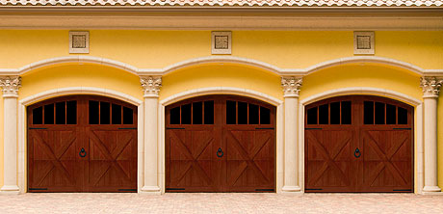
Wayne Dalton’s Model 7400 doors feature six distinctive patterns that radiate skilled craftsmanship. These flush doors, with their trim overlay, bring back the carriage style door look in a modern overhead sectional garage door. Choose from a multitude of facing options to create the exact door you desire or create your own custom door. If your builder or architect can draw it, we can build it!
Wood Garage Doors in the 7400 series combine the classic swing-open appearance and detailing of carriage house wood doors with the convenience of standard sectional garage doors.

Choose a Panel Design
Doors are available in both 7ft. and 8ft. but both have 4 panels. These garage doors are not customizable and not available in all areas. You may specify your door's facing in mahogany, MDO plywood*, tongue-in-groove cedar or T1-11 plywood. To maintain the look of a custom swinging door, clear cedar trim is applied in single pieces before cutting so the wood's grain matches down the full height of the door. The frame is kiln-dried hemlock with a polystyrene insulation core.

Single Car Garage Door Designs

7400 - Delmar
3 section
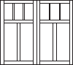 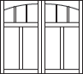 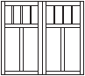 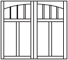 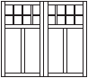 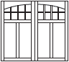

7401 - Preakness
3 section
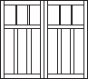 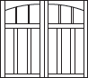 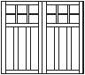 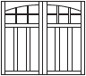 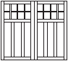 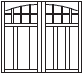

7402 - Churchill
3 section
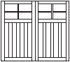 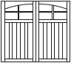 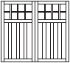 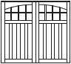 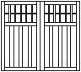 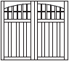

7410 - Saratoga
3 section
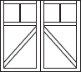 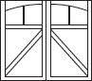 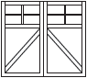 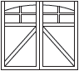 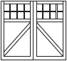 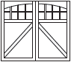

7411 - Belmont
3 section
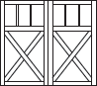 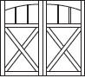 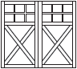 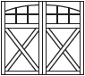 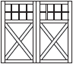 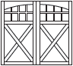

7412 - Derby
3 section
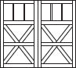 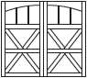 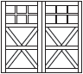 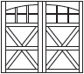 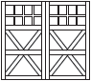 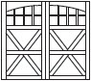

7420 - Cabriolet (Raised Wide Panels)
3 section
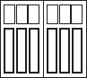 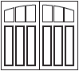 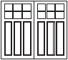 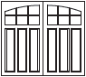 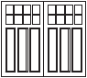 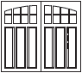

7421 - Brougham (Raised Narrow Panels)

Double Car Garage Door Designs

7400 - Delmar
3 section
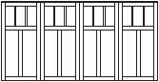 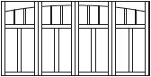 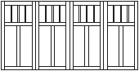 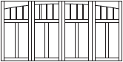 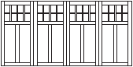 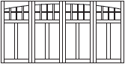

7401 - Preakness
3 section
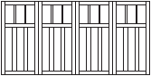 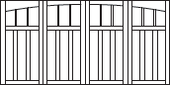 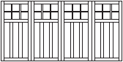 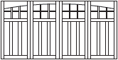 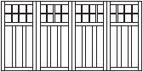 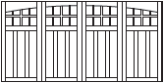

7402 - Churchill
3 section
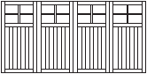 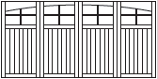 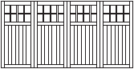 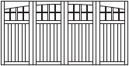 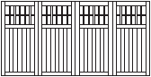

7410 - Saratoga
3 section
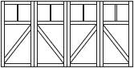 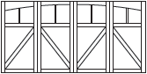 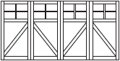 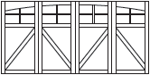 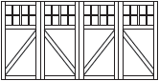 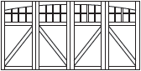

7411 - Belmont
3 section
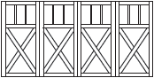 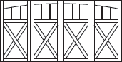 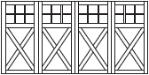 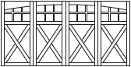 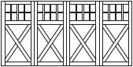 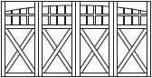

7412 - Derby
3 section
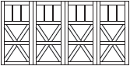 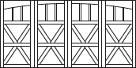 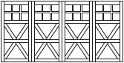 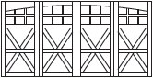 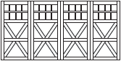 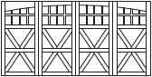

7420 - Cabriolet (Raised Wide Panels)
3 section
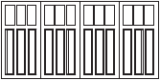 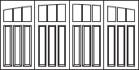 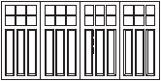 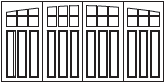 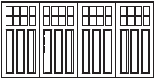 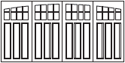

7421 - Brougham (Raised Narrow Panels)

Choose a Material
Our premium wood doors feature your choice of quality stain-grade or paint-grade woods such as Hemlock, Cedar, and Mahogany. Custom wood materials such as African Mahogany, Spanish Red Cedar and Birch are also available.
Hemlock
Cedar
Mahogany

Choose a Window
Windows are standard with 7400 models. They are true divided windows with individual glass separated by one inch mentions.
6 Arch
6 Square
8 Arch
8 Square
12 Arch
12 Square
16 arch
16 square

Choose Hardware
Every piece of our garage door hardware is made from black powder coated steel with a hand-hammered look. Additional accent pieces are available to match or complement each collection.

Euro Collection
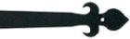
Fleur-de-Lis
Barcelona
Spear

The American Collection
Aspen
Conifer
Arrow

Black Wrought Iron Accents
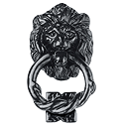
Lion's Head Knocker
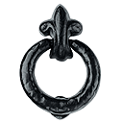
Fleur-de-Lis Knocker
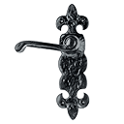
Fleur-de-Lis Lever Handle

Clavos & Studs
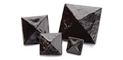
Pyramid
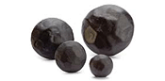
Round
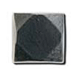
Studs

Hammered Knockers
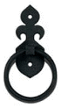
Fleur-de-Lis
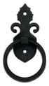
Barcelona
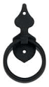
Spear
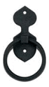
Aspen
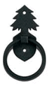
Conifer
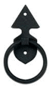
Arrow

Lift Handles
Fleur-de-Lis
Barcelona
Spear
Aspen
Conifer
Arrow

